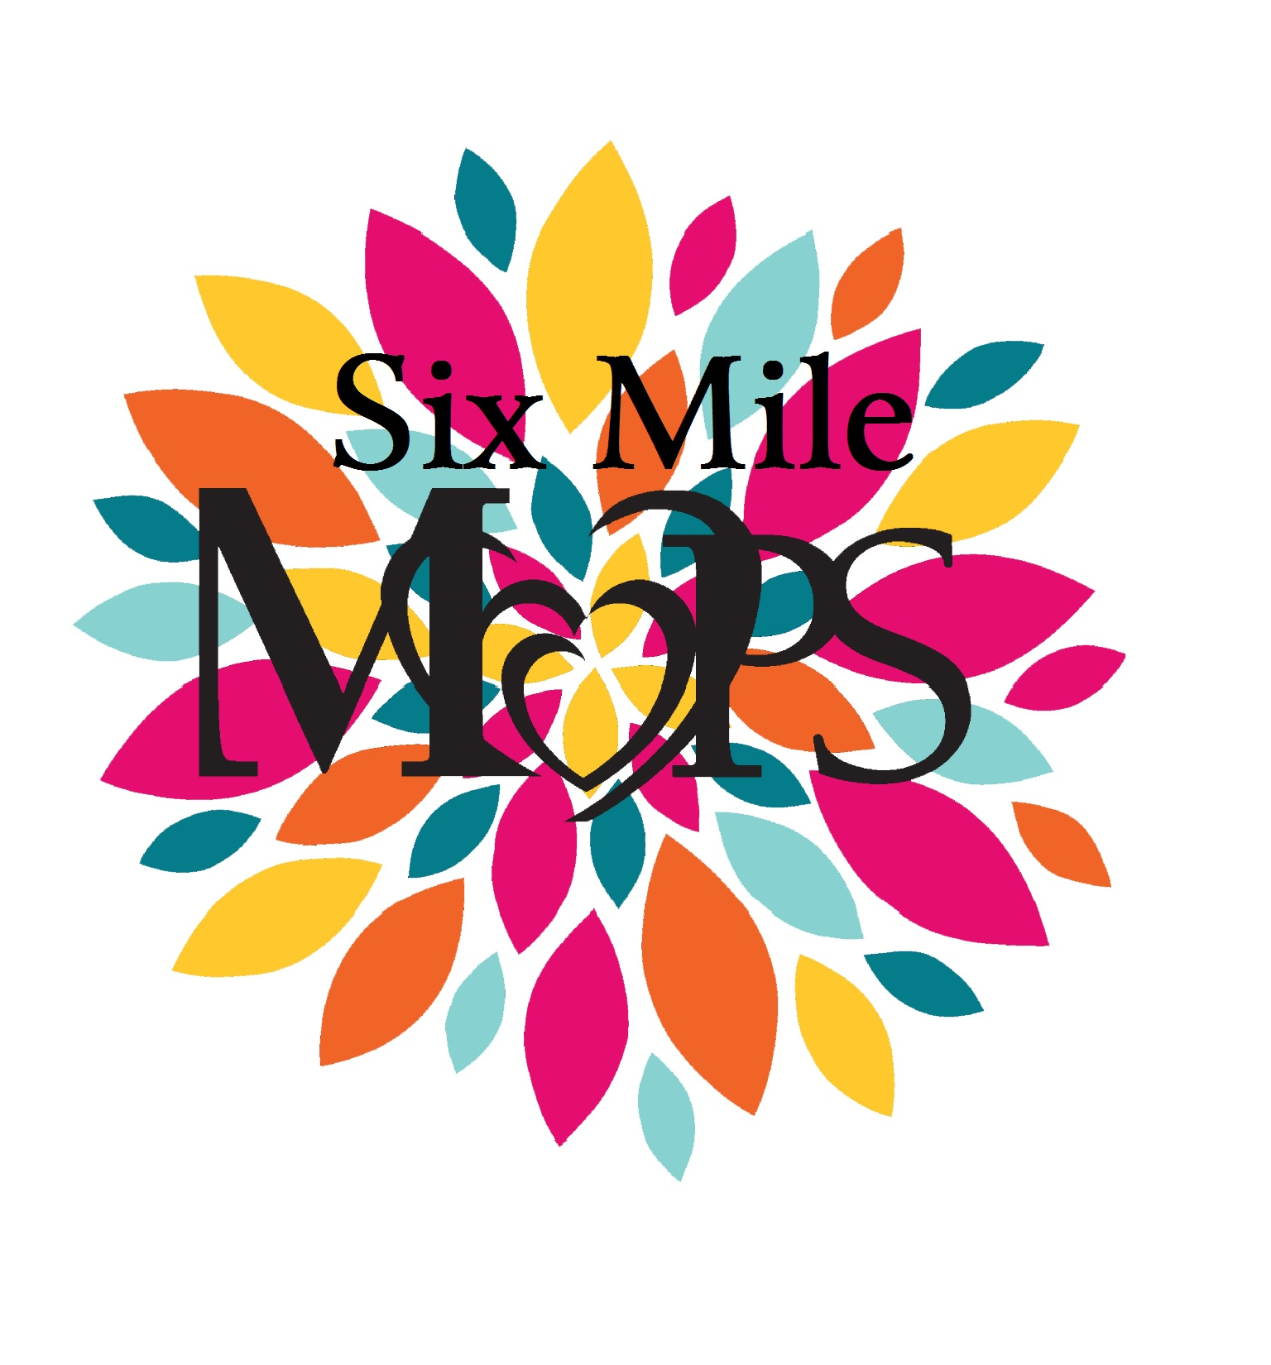
Consent to photograph
Consent to release information

I, _______________________________________, give my permission to use images/video of me and/or
my children (list children’s names)_________________________________________________________
_____________________________________________________________________________________
_____________________________________ for publicity or educational purposes by Six Mile MOPS
on the church’s bulletin board, group website, publicity materials, etc.

I understand that all materials will remain the property of Six Mile MOPS, and I am not entitled to any compensation or payment for their use.

Date: ____________________________________________________________

Signature: ____________________________________________________________ (parent/guardian signature required for minor)

